**KPI’s**

**select sum(total_price) as Total_Revenue from pizza_sales;**

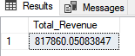

**select Sum (total_price) / Count(distinct order_id) as Avg_order_value from Pizza_sales;**



**select sum(quantity) as Total_pizza_sold from pizza_sales**



**select count(distinct order_id) as Total_order from pizza_sales**



**select cast(sum ( quantity)as decimal (10,2)) / cast(count( distinct order_id) as decimal (8,2)) as avg_pizza_per_order from pizza_sales;**



**select DATENAME(DW, order_date) as Order_date , count(distinct order_id) as Total_order**

**from pizza_sales**

**Group by DATENAME(DW, order_date)**

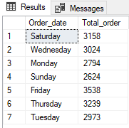

**select DATENAME(MONTH, order_date) as Month_name , count(distinct order_id) as Total_order**

**from pizza_sales**

**group by DATENAME(MONTH, order_date)**

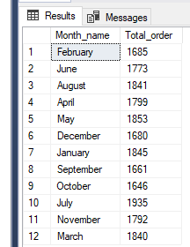

**select DATENAME(MONTH, order_date) as Month_name , count(distinct order_id) as Total_order**

**from pizza_sales**

**group by DATENAME(MONTH, order_date)**

**order by Total_order desc**

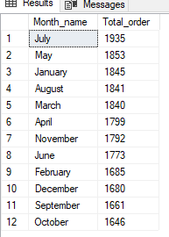

**select pizza_category, sum(total_price)*100/ (select sum(total_price) from pizza_sales)as Total_Revenue**

**from pizza_sales**

**group by pizza_category**

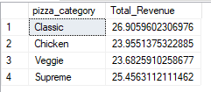

**select pizza_category,sum(Total_price) as Total_sales, sum(total_price)*100/ (select sum(total_price) from pizza_sales where month(order_date)=1 )as Total_Revenue**

**from pizza_sales**

**where month(order_date)=1**

**group by pizza_category**

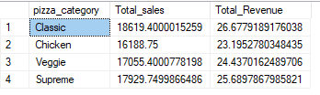

**select pizza_size, cast(sum(total_price) as decimal(20,2)) as Total_sales, cast(sum(total_price) * 100 / (select sum(total_price) from pizza_sales where datepart(Quarter, order_date)=1)**

**as decimal(5,2)) AS revenue from pizza_sales**

**where datepart(Quarter, order_date)=1**

**group by pizza_size**

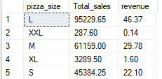

**select Top 5 pizza_name, sum(Total_price) as Total_revenue from pizza_sales**

**group by pizza_name**

**order by Total_revenue desc**

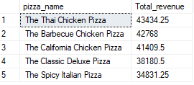

**select Top 5 pizza_name, sum(total_price) as Total_revenue , sum(quantity) as Total_quantity , count (distinct order_id) as Total_count from pizza_sales**

**group by pizza_name**

**order by Total_quantity desc**

